© [**audyvairefilevitasarialifia9@gmail.com**](mailto:audyvairefilevitasarialifia9@gmail.com)



Test Plan – Mini Project

Quality Engineer – Class A

9/5/2023

PT Marka Kreasi Persada

Audyva Irefilevitasari Alifia

 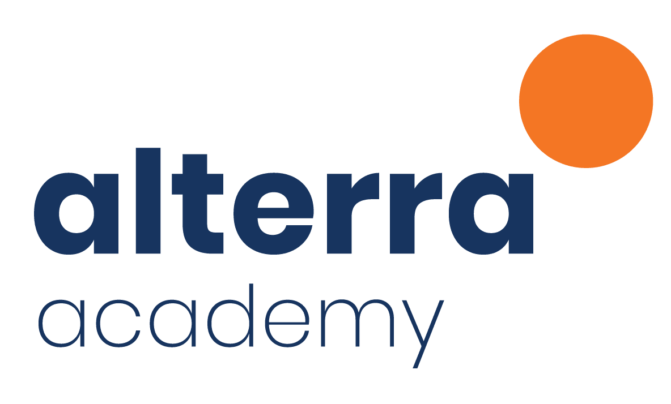

**Version:** 4.0

**Created:** 05/04/2023

**Last Updated:** 05/09/2023

**Status:** COMPLETED

**Revision and Signoff Sheet**

**Document History**

| **Version** | **Date** | **Author** | **Description of Change** |
| --- | --- | --- | --- |
| 1 | 05/04/2023 | Audyva Irefilevitasari Alifia | Draft |
| 2 | 05/08/2023 | Audyva Irefilevitasari Alifia | Draft |
| 3 | 05/09/2023 | Audyva Irefilevitasari Alifia | Draft - Reviewed |
| **4** | **05/09/2023** | **Audyva Irefilevitasari Alifia** | **Completed** |

**Approvers List**

| Name | Role | Approver / Reviewer | Approval / Review Date |
| --- | --- | --- | --- |
| **Trino Hutasoit** | **Mentor. Evaluator** |  |  |
|  |  |  |  |
|  |  |  |  |
|  |  |  |  |
|  |  |  |  |
|  |  |  |  |
|  |  |  |  |

**Reference Documents**

| **Version** | **Date** | **Document Name** |
| --- | --- | --- |
| 1.0 | 05/04/2023 | Live-Project_Test-Plan_MiniProject |
| 2.0 | 05/08/2023 | Quality Engineer Test Plan-Alterra Mini Project_Audyva-Irefilevitasari-Alifia |
| 3.0 | 05/09/2023 | Test Plan of Mini Project_ By-Audyva Irefilevitasari-Alifia_Quality-Engineer-Class-A_PT-Marka-Kreasi-Persada-Alterra |
| 4.0 | 05/09/2023 | Test Plan of Mini Project_ By-Audyva Irefilevitasari-Alifia_Quality-Engineer-Class-A_PT-Marka-Kreasi-Persada-Alterra |

**Table of Contents**

1. INTRODUCTION 3

1.1. Purpose 3

1.2. Project Overview 3

1.3. Audience 3

1.4. Requirement for Test 4

2. TEST STRATEGY 4

2.1. Test Types 4

2.2. Test Tools 7

2.3. Test Principles 8

2.4. Resource System 8

2.5. Software Test 8

3. PROJECT MILESTONES 8

4. TEST ENVIRONMENT 8

5. RESULTS 9

6. APPROVALS 12

# INTRODUCTION

A test plan is a document that outlines the objectives, resources, and processes for a specific software test. The test plan document in this case pertains to the Altashop Website, API, and App, specifically the frontend_mobile system, and explains how the software will run based on pre-set requirements. The aim of the test plan is to test the software's suitability against the goals set during project planning. By creating a detailed test plan, all aspects of the software can be covered, and the design results can be verified against the development plan.

## Purpose

The purpose of the test plan document is to ensure that the API, Web, and Mobile products of Alta Shop comply with predetermined requirements. The document specifies the objectives, resources, and processes for a specific test to be conducted on the software products. It identifies the features or components of the software that need to be tested, the type of testing to be applied, the required resources, and the estimated test efforts. Additionally, the document lists the deliverable elements of the test activities. By establishing clear and measurable test steps, the test plan document ensures that all aspects of the software are covered, and the results of the design are in accordance with the development plan.

## Project Overview

Software testing is a critical process that verifies whether a software product or application performs as intended and aligns with the requirements set. Testing is essential in identifying possible bugs or defects that may appear in the system. To conduct testing efficiently, a test plan document is necessary. This document serves as a reference for conducting tests, ensuring that the expected goals and results can be achieved. By following the test plan, all aspects of the software can be covered, and the design results can be verified against the development plan established during project planning. Overall, software testing plays a vital role in ensuring that software products or applications meet the required standards and perform as intended.

## Audience

The audience for this document is anyone involved in testing the API, Altashop Web, and Mobile App. The scope of testing includes functionality, user interface, and automation testing for each feature on the web and mobile app, as well as manual and automation testing for the API. Testing for the web UI involves features such as authorized user, homepage, cart, pay, and transaction, while testing for the mobile app includes the same features, except for auth and homepage. The API testing covers manual and automation testing for the API URL, which can be found at https://documenter.getpostman.com/view/5781191/2s8YmULKUi#3f60955e-6718-48aa-811a-0c62aff3ed75.

## Requirement for Test

The testing requirements for the AltaShop system encompass the Web UI, API, and Mobile. To accomplish this, several tools are used, including:

1. Microsoft Excel for test documentation
2. Intellij IDEA CE for automation testing for AltaShop Website
3. Google Chrome Driver for run web automation testing
4. Pixel 2 API 30 from Android Studio and Katalon for mobile testing
5. Microsoft Word for document test and report

# TEST STRATEGY

## Test Types

| Object to Test | Testing Types | Test Planning and Test Design | Details |
| --- | --- | --- | --- |
| API | Manual | Test Objective | The primary objective of this testing plan is to evaluate the functionality of each URL and verify the response code and output. This will help ensure that the software products meet the predetermined requirements and are fit for purpose. |
| Technique | The testing technique will involve testing each URL using different methods and test data. This will enable us to identify any issues or defects in the software and ensure that the results of the design align with the development plan established during project planning. The HTTP response code and output will be verified to confirm that they align with the inputs and transactions made. |
| Completion Criteria | The completion criteria for this test plan are that each URL must function correctly. Additionally, the output and response code must align with the inputs and transactions made. By establishing clear and measurable test steps, this test plan document ensures that all aspects of the software are covered, and the results of the design are in accordance with the development plan previously made. |
| Automation | Test Objective | The primary objective of the testing is to ensure that all URLs in the Altashop system are functional and produce the correct response codes and outputs. This will involve verifying the proper functionality of each URL. |
| Technique | To achieve the test objective, several techniques will be employed, including testing each URL using different methods and test data. Additionally, the HTTP response code and output will be verified to ensure they align with the expected inputs and transactions made. The testing will be conducted using automation in Serenity. |
| Completion Criteria | To meet the test objective, the following completion criteria will be used. Firstly, each URL in the Altashop system should function properly. Secondly, the output and response code of each URL must be in accordance with the inputs and transactions performed. These criteria will ensure that the Altashop system operates correctly and meets the required standards. |
| Web | Manual | Test Objective | The test objective is to ensure that all form inputs that require data input can perform the necessary input to the database or for processing. |
| Technique | The technique involves testing each button on the form and testing the input form with various input conditions to ensure that all input fields can be properly processed. |
| Completion Criteria | The completion criteria for this test are that each field form can input data to be processed properly and that the output must be in accordance with the inputs and transactions made. |
| Automation | Test Objective | The objective of the test is to ensure that all forms requiring input data can properly input data to the database or for processing. |
| Technique | To achieve this objective, the following techniques will be used:   * Testing each button on the form to ensure it performs the intended action. * Testing the input form with various input conditions to check for any errors or unexpected behavior. * Using automation in Serenity BDD to automate the testing process and increase efficiency. |
| Completion Criteria | The completion criteria for the test are as follows:   * Each field form can input data to be processed properly. * The output of the form must be in accordance with the inputs and the transactions that have been made. |
| Mobile | Manual | Test Objective | The test objective is to ensure that all form inputs that require data input can perform the necessary input to the database or for processing. |
| Technique | The technique involves testing each button on the form and testing the input form with various input conditions to ensure that all input fields can be properly processed. |
| Completion Criteria | The completion criteria for this test are that each field form can input data to be processed properly and that the output must be in accordance with the inputs and transactions made. |
| Automation | Test Objective | The primary objective of the testing is to ensure that all URLs in the Altashop system are functional and produce the correct response codes and outputs. This will involve verifying the proper functionality of each URL. |
| Technique | To achieve the test objective, several techniques will be employed, including testing each URL using different methods and test data. Additionally, the HTTP response code and output will be verified to ensure they align with the expected inputs and transactions made. The testing will be conducted using automation in Katalon with Pixel 2 API 30 of Android Studio. |
| Completion Criteria | To meet the test objective, the following completion criteria will be used. Firstly, each URL in the Altashop system should function properly. Secondly, the output and response code of each URL must be in accordance with the inputs and transactions performed. These criteria will ensure that the Altashop system operates correctly and meets the required standards. |

## Test Tools

| Types of Testing | Tool | Vendor | Version |
| --- | --- | --- | --- |
| Automation Testing Tools for API | Intellij IDEA CE | Serenity | 2022.2.1 |
| Automation Testing Tools for Web | Intellij IDEA CE | Serenity | 2022.2.1 |
| Automation Testing Tools for Mobile | Katalon | Katalon, Inc | 2.0 |
| Android Control Tools/Emulator | Pixel 2 API 30 | Android Studio | 2021.2.1 |
| Document Test Case | Google Spreadsheets | Google Suites | - |
| Document Test Plan and Report | Google Docs | Google Suites | - |
| CI/CD Pipeline | Github Actions | Github | V2 |

## Test Principles

The following are the principles that will guide the testing process:

* + The testing activities will be designed to meet the business objectives, achieve cost efficiency, and ensure quality.
  + All teams involved in testing will follow common and consistent procedures.
  + The testing processes will be well-defined but flexible enough to adapt to changing needs.
  + Testing activities will build on previous stages to avoid redundancy or duplication of effort.
  + The testing environment and data will resemble a production environment as closely as possible.
  + Testing will be a repeatable, quantifiable, and measurable activity.
  + The testing process will be divided into distinct phases, each with clear objectives and goals.
  + Entrance and exit criteria will be established to ensure the testing process is effective.

## Resource System

* + Web UI: <https://alta-shop.vercel.app/>
  + API: <https://altashop-api.fly.dev/api/>
  + API Postman Documentation: <https://documenter.getpostman.com/view/5781191/2s8YmULKUi#3f60955e-6718-48aa-811a-0c62aff3ed75>
  + Mobile: <https://drive.google.com/file/d/1k8aMWoXyIhzRrsLWNPAr54LJarD9o-ul/view>

## Software Test

* Google Spreadsheet
* Intellij IDEA CE
* Android Studio
* Katalon
* Github Actions

# PROJECT MILESTONES

| No | Milestone Task | Start date | End date |
| --- | --- | --- | --- |
| 1 | Plan Test | 04/15/2023 | 04/16/2023 |
| 2 | Design Test | 04/17/2023 | 04/18/2023 |
| 3 | Implement Test | 04/19/2023 | 05/06/2023 |
| 4 | Execute Tests | 04/20/2023 | 05/07/2023 |
| 5 | Report Test | 05/04/2023 | 05/09/2023 |

# TEST ENVIRONMENT

The hardware standards that will be used to perform software testing are:

* VICTUS By HP Edition : Windows 11 Home Single Language
* Version : 25/‎02/‎2023
* OS build : 22621.1555
* Experience : Windows Feature Experience Pack 1000.22640.1000.0
* Processor : AMD Ryzen 5 5600H with Radeon Graphics 3.30 GHz
* Installed RAM : 16,0 GB (15,3 GB usable)
* System type : 64-bit operating system, x64-based processor

# RESULTS

1. Web AltaShop Manual Testing (83,67% success)

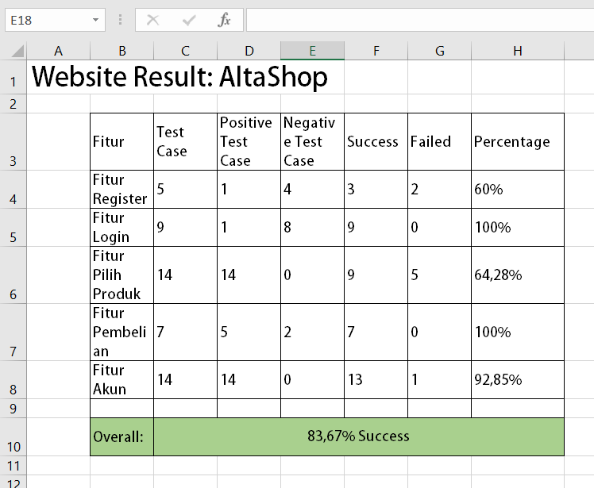

1. Mobile frontend_mobile Manual Testing (81,81% success)

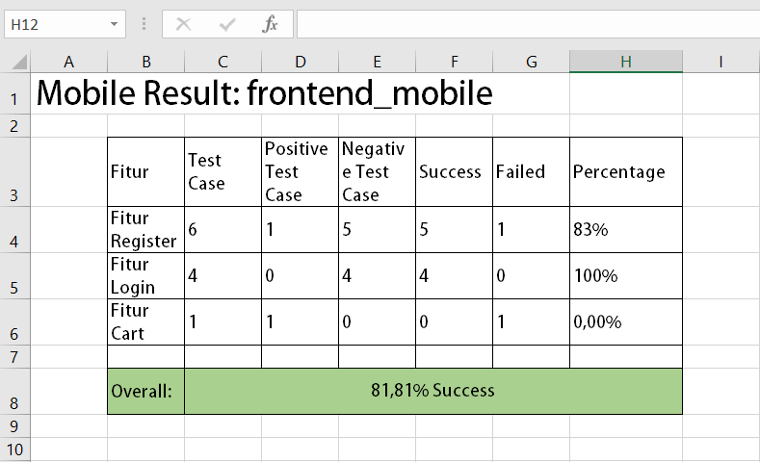

1. Web UI AltaShop Automation Testing (100% success)

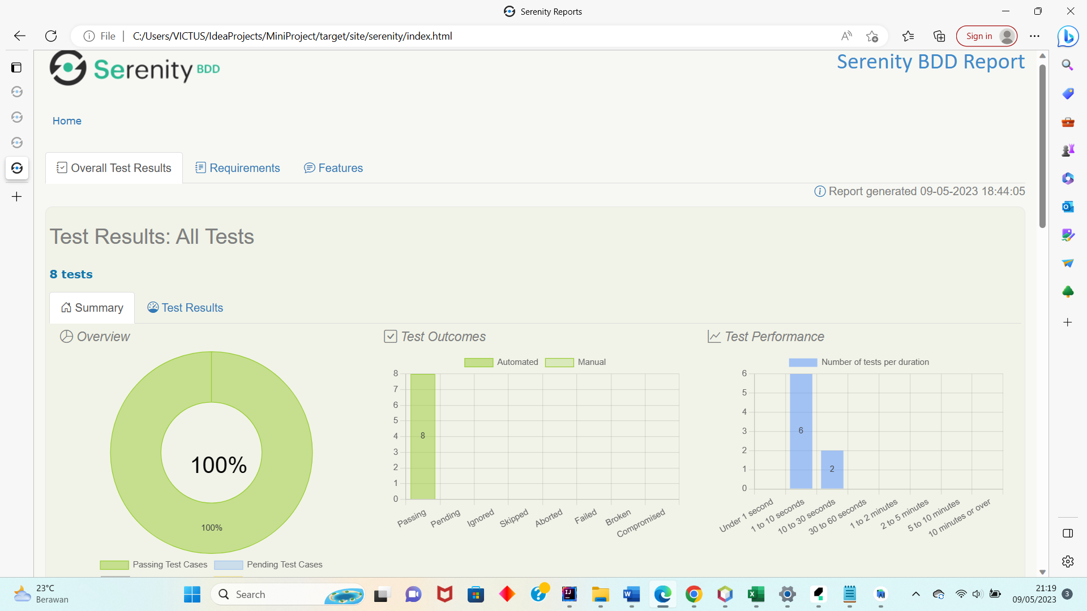

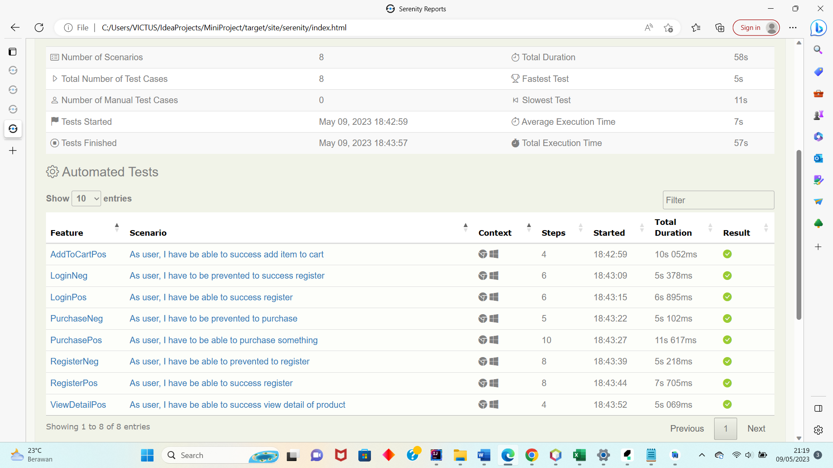

1. Mobile frontend_mobile Automation Testing (0% success)

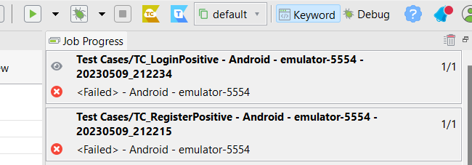

1. Web AltaShop REST Assured Testing (100% success)

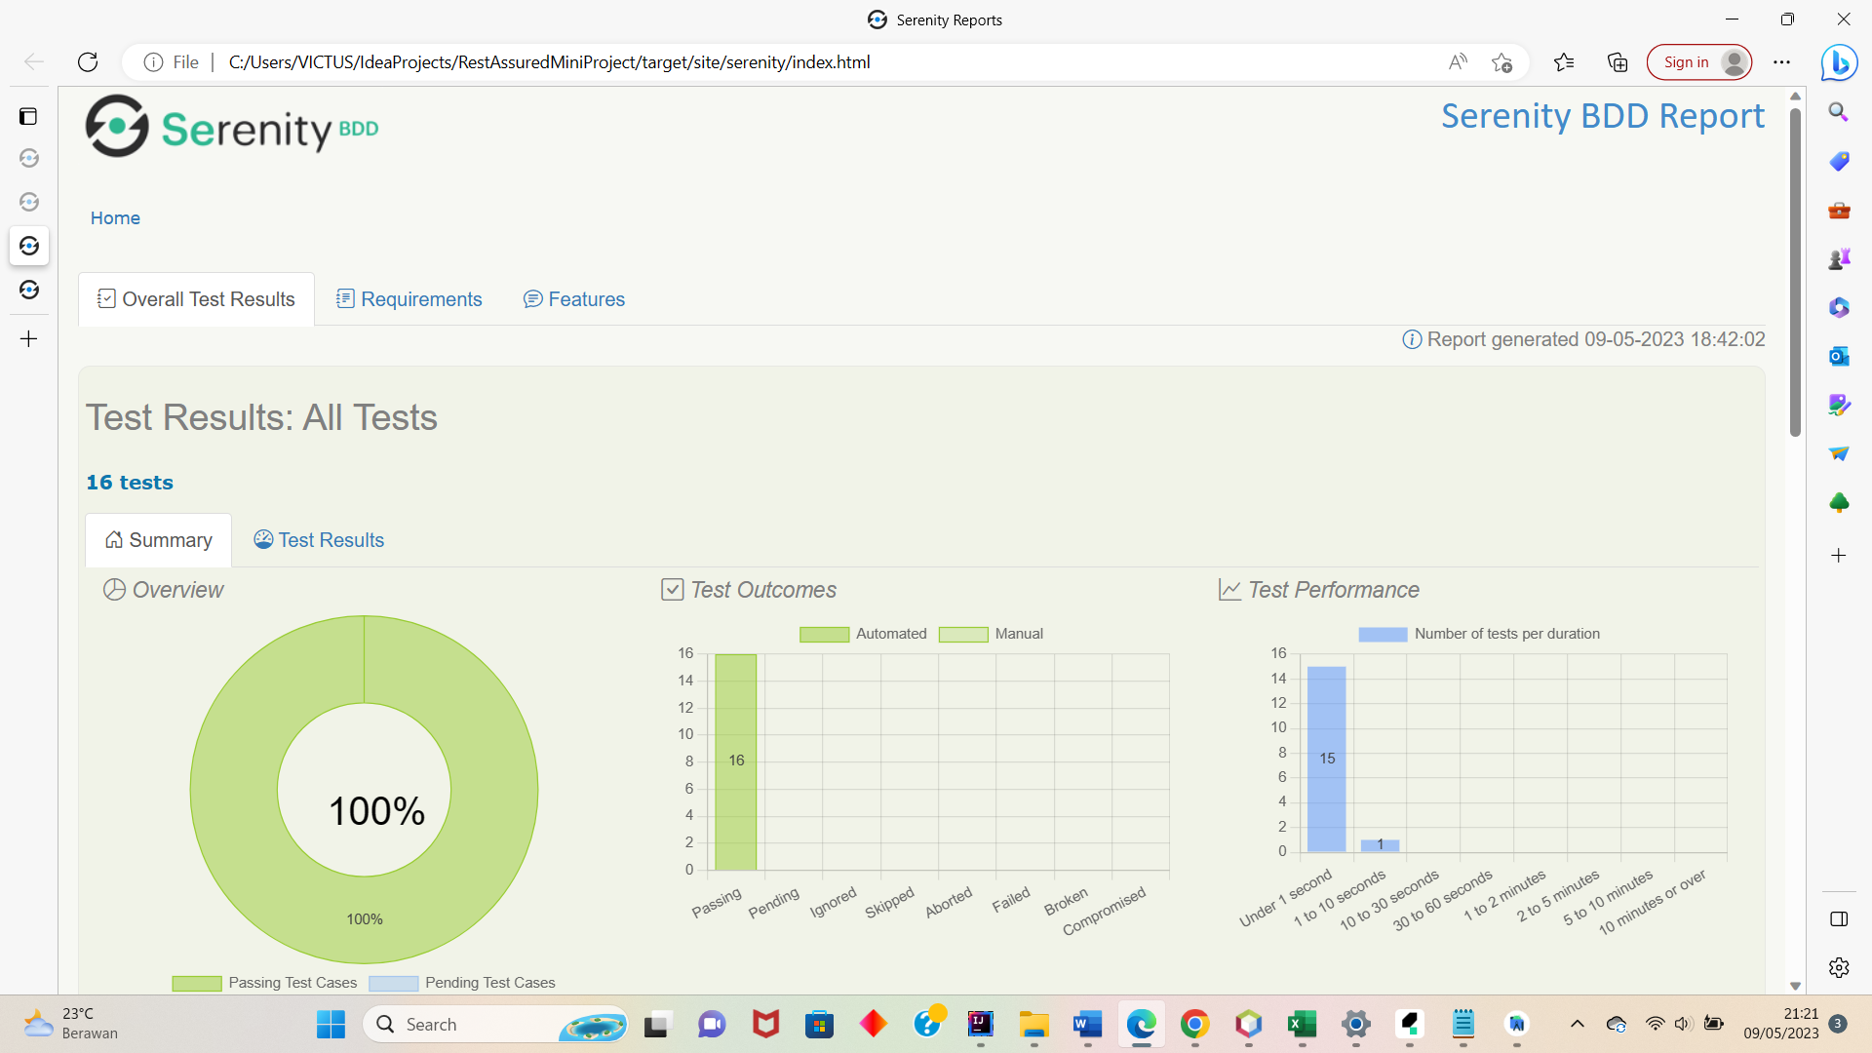

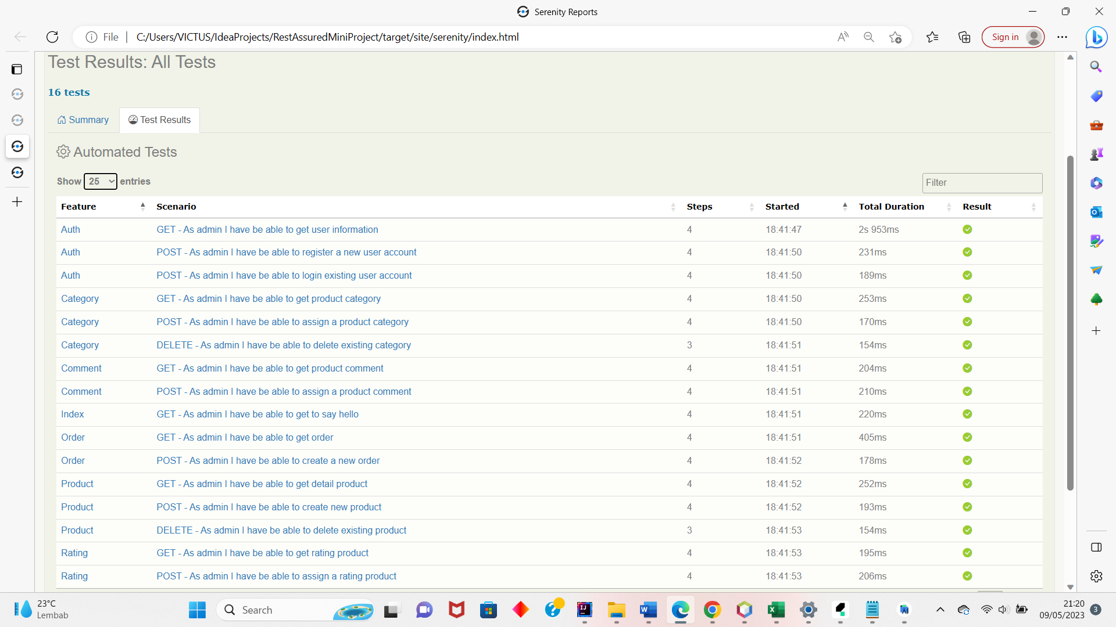

1. CI/CD Pipeline

<https://github.com/audyvaalifia/CICD-Pipeline-MiniProject/actions>

# APPROVALS

The Names and Titles of all persons who must approve this plan.

| **Signature:** |  |
| --- | --- |
| **Name:** | Audyva Irefilevitasari Alifia |
| **Role:** | Individual Quality Engineer |
| **Date:** | 05/09/2023 |

| **Signature:** |  |
| --- | --- |
| **Name:** | Trino Hutasoit |
| **Role:** | Mentor, Evaluator |
| **Date:** | 05/09/2023 |